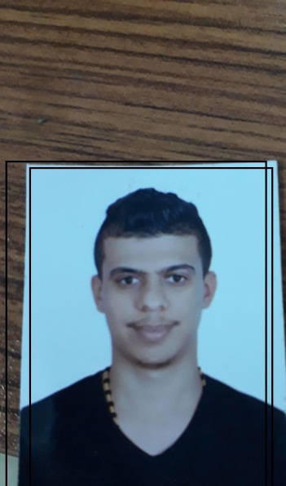

**Curriculum Vitae**

House 2444 Road 1640 Block 1213 1 Hamad Town 22

Mobile No.:37109975

E-mail a2_ali_a@hotmail.com

|  |  |
| --- | --- |
| PERSONAL DETAILS |  |

**Name:** Ali Mohd Ridha Isa Ahmed Hassan

**Date of Birth:** 12 March 1996

**Place of Birth:** Jidhafs

**CPR Number:** 960303863

**Nationality:** Bahraini

**Marital Status:** Single

|  |  |
| --- | --- |
| OBJECTIVE |  |

To obtain a position that would allow me to maximize my management skills, helps me in

developing myself and to widen my knowledge.

|  |  |
| --- | --- |
| ACADEMIC QUALIFICATIONS |  |

Education:

Al - Jabriya Secondary Industrial School

Graduation:

2014/06/16

High School

**Languages:**

**Mother language**: Arabic

**Other Languages:** English

|  |  |
| --- | --- |
| CORE SKILLS |  |

**Communication skills:**

* the ability to transfer the idea and information clearly to others
* Ability to handle work under pressure
* Capable to build good relationships with others
* Mature and self-confident
* Strong verbal and personal communication skills.
* Self-motivated, initiative, high level of energy
* Accuracy and Attention to details.
* Tolerant and flexible

**Computer skills:**

* Microsoft Office (word , PowerPoint , etc)

**WORK EXPERIENCE:**

* Al-Faris Food Factory AS Employee IN 2018
* Security Guard Company (ISMCO) AS SECURITY IN 2018
* Al - Moayad Security Company AS SECURITY IN 2017

|  |  |
| --- | --- |
| REFERENCES |  |

* Available upon request